Maven Spring-Web Swagger2

Swagger 是一個規範和完整的框架，用於產生、描述、呼叫和視覺化RESTful 風格的Web 服務。總體目標是使客戶端和檔案系統作為伺服器以相同的速度來更新。檔案的方法，參數和模型緊密整合到伺服器端的程式碼，允許API來始終保持同步。

下面透過實作一個web專案來示範Swagger的使用。
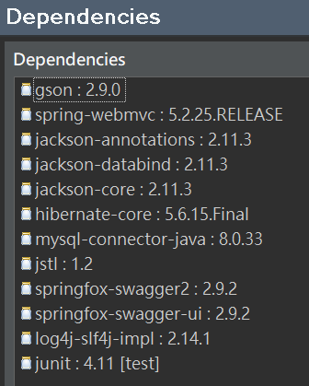
pom.xml
<dependency>
<groupId>com.google.code.gson</groupId>
<artifactId>gson</artifactId>
<version>2.9.0</version>
</dependency>
<!-- Spring WebMVC -->
<dependency>
<groupId>org.springframework</groupId>
<artifactId>spring-webmvc</artifactId>
<version>5.2.25.RELEASE</version>
</dependency>

<dependency>
<groupId>com.fasterxml.jackson.core</groupId>
<artifactId>jackson-annotations</artifactId>
<version>2.11.3</version>
</dependency>
<dependency>
<groupId>com.fasterxml.jackson.core</groupId>
<artifactId>jackson-databind</artifactId>
<version>2.11.3</version>
</dependency>
<dependency>
<groupId>com.fasterxml.jackson.core</groupId>
<artifactId>jackson-core</artifactId>
<version>2.11.3</version>
</dependency>

<dependency>
<groupId>org.hibernate</groupId>
<artifactId>hibernate-core</artifactId>
<version>5.6.15.Final</version>
</dependency>
<dependency>
<groupId>mysql</groupId>
<artifactId>mysql-connector-java</artifactId>
<version>8.0.33</version>
</dependency>
<dependency>
<groupId>javax.servlet</groupId>
<artifactId>jstl</artifactId>
<version>1.2</version>
</dependency>

<!-- Swagger2 for API documentation -->
<dependency>
<groupId>io.springfox</groupId>
<artifactId>springfox-swagger2</artifactId>
<version>2.9.2</version>
</dependency>
<dependency>
<groupId>io.springfox</groupId>
<artifactId>springfox-swagger-ui</artifactId>
<version>2.9.2</version>
</dependency>

<dependency>
<groupId>org.apache.logging.log4j</groupId>
<artifactId>log4j-slf4j-impl</artifactId>
<version>2.14.1</version>
</dependency>

web.xml
<?xml version="1.0" encoding="UTF-8"?>
<web-app xmlns:xsi="http://www.w3.org/2001/XMLSchema-instance" xmlns="http://xmlns.jcp.org/xml/ns/javaee" xsi:schemaLocation="http://xmlns.jcp.org/xml/ns/javaee http://xmlns.jcp.org/xml/ns/javaee/web-app_4_0.xsd" id="WebApp_ID" version="4.0">
<display-name>mvweb1108</display-name>
<welcome-file-list>
<welcome-file>index.html</welcome-file>
<welcome-file>index.jsp</welcome-file>
<welcome-file>index.htm</welcome-file>
<welcome-file>default.html</welcome-file>
<welcome-file>default.jsp</welcome-file>
<welcome-file>default.htm</welcome-file>
</welcome-file-list>
<servlet>
<servlet-name>dispatcher</servlet-name>
<servlet-class>
org.springframework.web.servlet.DispatcherServlet
</servlet-class>
<load-on-startup>1</load-on-startup>
</servlet>
<servlet-mapping>
<servlet-name>dispatcher</servlet-name>
<url-pattern>/</url-pattern>
</servlet-mapping>
</web-app>

dispatcher-servlet.xml

<?xml version="1.0" encoding="UTF-8"?>
<beans xmlns="http://www.springframework.org/schema/beans"
xmlns:xsi="http://www.w3.org/2001/XMLSchema-instance"
xmlns:p="http://www.springframework.org/schema/p"
xmlns:context="http://www.springframework.org/schema/context"
xmlns:mvc="http://www.springframework.org/schema/mvc"
xsi:schemaLocation="http://www.springframework.org/schema/beans
http://www.springframework.org/schema/beans/spring-beans-4.1.xsd
http://www.springframework.org/schema/context
http://www.springframework.org/schema/context/spring-context-4.1.xsd
http://www.springframework.org/schema/mvc
http://www.springframework.org/schema/mvc/spring-mvc-4.1.xsd">

<context:component-scan base-package="com.springformmvc"/>
<context:annotation-config/>
<mvc:annotation-driven></mvc:annotation-driven>
<mvc:resources mapping="swagger-ui.html" location="classpath:/META-INF/resources/" />
<mvc:resources mapping="/webjars/**" location="classpath:/META-INF/resources/webjars/" />

<bean class="org.springframework.web.servlet.view.InternalResourceViewResolver">
<property name="prefix">
<value>/WEB-INF/jsp/</value>
</property>
<property name="suffix">
<value>.jsp</value>
</property>
</bean>
</beans>

SwaggerConfig.java

package com.springformmvc;

import org.springframework.context.annotation.Bean;
import org.springframework.context.annotation.Configuration;
import springfox.documentation.builders.ApiInfoBuilder;
import springfox.documentation.builders.RequestHandlerSelectors;
import springfox.documentation.spi.DocumentationType;
import springfox.documentation.spring.web.plugins.Docket;
import springfox.documentation.swagger2.annotations.EnableSwagger2;

@Configuration
@EnableSwagger2
public class SwaggerConfig {
@Bean
public Docket api() {
return new Docket(DocumentationType.SWAGGER_2)
.select()
.apis(RequestHandlerSelectors.basePackage("com.springformmvc"))
.build()
// .pathMapping("/mvSpringSwagger1107") // Set the path mapping
.apiInfo(new ApiInfoBuilder().title("Person API").build());
}
}

Entity Class
package model;
public class Person {
private Long id;
private String firstName;
private String lastName;
private int age;
public Person(Long id, String firstName, String lastName, int age) {
this.id = id;
this.firstName = firstName;
this.lastName = lastName;
this.age = age;
}
public Person() {}

public Long getId() {
return id;
}
public void setId(Long id) {
this.id = id;
}
public String getFirstName() {
return firstName;
}
public void setFirstName(String firstName) {
this.firstName = firstName;
}
public String getLastName() {
return lastName;
}

public void setLastName(String lastName) {
this.lastName = lastName;
}
public int getAge() {
return age;
}
public void setAge(int age) {
this.age = age;
}
}

Controller:

package com.springformmvc;

import org.springframework.stereotype.Controller;
import org.springframework.web.bind.annotation.*;
import springfox.documentation.annotations.ApiIgnore;
import java.util.ArrayList;
import java.util.List;
import model.*;

// http://localhost:8080/mvSpringSwagger1107/swagger-ui.html
@Controller
@RequestMapping("/persons")
public class PersonController {
private List<Person> persons = new ArrayList<>();
private long idCounter = 1;

// Create a new person
@PostMapping
@ResponseBody
public Person createPerson(@RequestBody Person person) {
person.setId(idCounter++);
persons.add(person);
return person;
}

// Retrieve a person by ID
@GetMapping("/{id}")
@ResponseBody
public Person getPerson(@PathVariable Long id) {
for (Person person : persons) {
if (person.getId().equals(id)) {
return person;
}
}
throw new RuntimeException("Person not found");
}

// Update a person
@PutMapping("/{id}")
@ResponseBody
public Person updatePerson(@PathVariable Long id, @RequestBody Person updatedPerson) {
for (int i = 0; i < persons.size(); i++) {
if (persons.get(i).getId().equals(id)) {
updatedPerson.setId(id);
persons.set(i, updatedPerson);
return updatedPerson;
}
}
throw new RuntimeException("Person not found");
}

// Delete a person
@DeleteMapping("/{id}")
@ResponseBody
public void deletePerson(@PathVariable Long id) {
persons.removeIf(person -> person.getId().equals(id));
}

// Retrieve all persons
@GetMapping
@ResponseBody
public List<Person> getAllPersons() {
return persons;
}

// This method is annotated with @ApiIgnore to exclude it from Swagger documentation
@ApiIgnore
@GetMapping("/hidden")
@ResponseBody
public String hiddenEndpoint() {
return "This endpoint is hidden in Swagger documentation.";
}
}

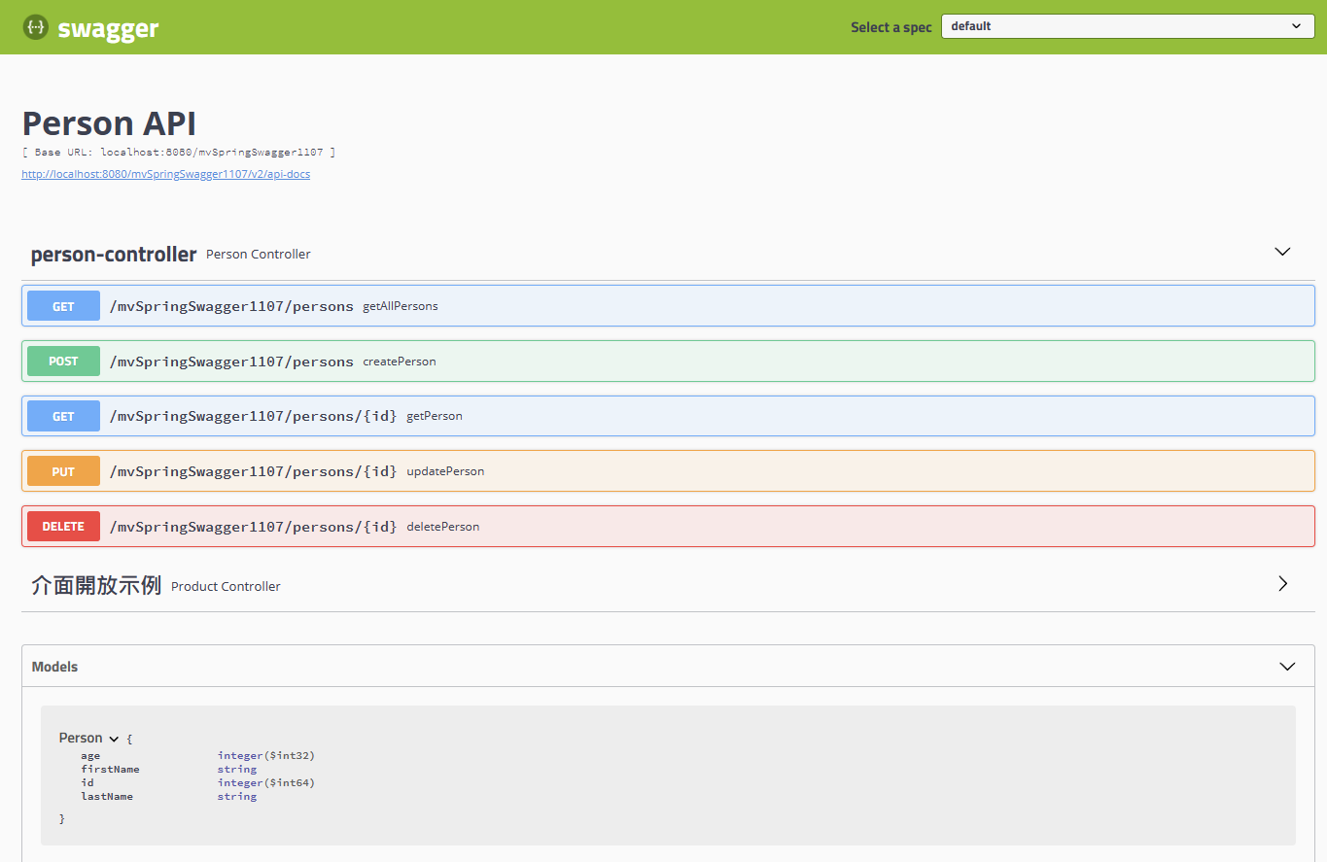

加入控制器API說明:
package model;
public class Product {
private Long id;
private String name;
private String productClass;
private String productId;
public Long getId() {
return id;
}
public void setId(Long id) {
this.id = id;
}
public String getName() {
return name;
}

public void setName(String name) {
this.name = name;
}
public String getProductClass() {
return productClass;
}
public void setProductClass(String productClass) {
this.productClass = productClass;
}
public String getProductId() {
return productId;
}
public void setProductId(String productId) {
this.productId = productId;
}
@Override
public String toString() {
return "Product [id=" + id + ", name=" + name + ", productClass="
+ productClass + ", productId=" + productId + "]";
}
}

/*
常用注解：

@Api()用於類別； 表示標識這個類別是swagger的資源
@ApiOperation()用於方法； 表示一個http請求的操作
@ApiParam()用於方法，參數，欄位說明； 表示對參數的添加中繼資料（說明或是否必填等）
@ApiModel()用於類別 表示對類別進行說明，用於參數用實體類別接收
@ApiModelProperty()用於方法，欄位 ；表示對model屬性的說明或者資料操作更改
@ApiIgnore()用於類別，方法，方法參數 ；表示這個方法或者類別被忽略
@ApiImplicitParam() 用於方法 ；表示單獨的請求參數
@ApiImplicitParams() 用於方法，包含多個 @ApiImplicitParam

*/
package com.springformmvc;

import java.util.Arrays;
import java.util.List;

import org.springframework.http.ResponseEntity;
import org.springframework.web.bind.annotation.PathVariable;
import org.springframework.web.bind.annotation.RequestMapping;
import org.springframework.web.bind.annotation.RequestMethod;
import org.springframework.web.bind.annotation.RestController;

import io.swagger.annotations.Api;
import io.swagger.annotations.ApiOperation;
import io.swagger.annotations.ApiResponse;
import io.swagger.annotations.ApiResponses;
import model.*;

@RestController
@RequestMapping(value = { "/products" })
// 類別上加@Api注解
@Api(value = "/ProductController", tags = "api開放範例")
public class ProductController {
@RequestMapping(value = "/{id}", method = RequestMethod.GET)
// 方法上加ApiOpreation注解
@ApiOperation(value = "根據id獲取產品資訊", notes = "根據id獲取產品資訊", httpMethod = "GET", response = Product.class)
public ResponseEntity<Product> get(@PathVariable Long id) {
Product product = new Product();
product.setName("空氣清淨機");
product.setId(1L);
product.setProductClass("filters");
product.setProductId("T12345");
return ResponseEntity.ok(product);
}

@RequestMapping(method = RequestMethod.POST)
@ApiOperation(value = "新增一個新的產品")
@ApiResponses(value = { @ApiResponse(code = 405, message = "參數錯誤") })
public ResponseEntity<String> add(Product product) {
return ResponseEntity.ok("SUCCESS");
}

@RequestMapping(method = RequestMethod.PUT)
@ApiOperation(value = "更新一個產品")
@ApiResponses(value = { @ApiResponse(code = 400, message = "參數錯誤") })
public ResponseEntity<String> update(Product product) {
return ResponseEntity.ok("SUCCESS");
}

@RequestMapping(method = RequestMethod.GET)
@ApiOperation(value = "獲取所有產品資訊", notes = "獲取所有產品資訊", httpMethod = "GET", response = Product.class, responseContainer = "List")
public ResponseEntity<List<Product>> getAllProducts() {
Product product = new Product();
product.setName("七級濾芯淨水器");
product.setId(1L);
product.setProductClass("seven_filters");
product.setProductId("T12345");
return ResponseEntity.ok(Arrays.asList(product, product));
}
}

